UNIFORM ORDER
ORDER DATE:
ATHLETE NAME:
CONTACT NUMBER:
EMAIL:
COACH:

UNIFORM TYPE |  | SIZE | QTY | UNIT PRICE | TOTAL
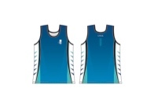 | MENS SINGLET  B12, B14, 2XS, XS, S, M, L, XL, 2XL |  |  | $35.00 | $
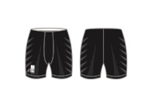 | MEN’S BIKE PANTS  XXS, XS, S, M, L, XL |  |  | $35.00 | $
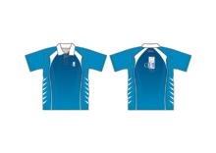 | MEN’S POLO SHIRT  S, M, L, XL, 2XL |  |  | $40.00 | $
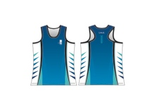 | WOMEN’S SINGLET  G12, G14, L8, L10, L12, L14, L16, L18, L20 |  |  | $35.00 | $
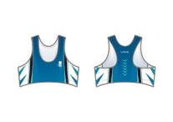 | WOMEN’S CROP TOP  G14, L8, L10, L12, L14, L16 |  |  | $35.00 | $
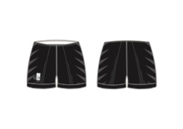 | WOMEN’S HOT PANTS  G14, L8, L10, L12, L14, L16 |  |  | $35.00 | $
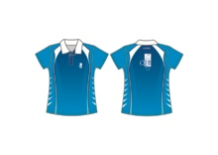 | WOMEN’S POLO SHIRT  L8, L10, L12, L14, L16, L18, L20 |  |  | $40.00 | $
 |  |  |  | SUBTOTAL: | $
RECEIPT NUMBER: |  |  |  | POSTAGE: | $
 |  |  |  | TOTAL: | $

- Please email order form to inquiries@qe2trackclub.com.
- Pickup from QSAC Track from Annette Rice.
- Cash payments are only accepted at time of pickup or prior arrangements.
- Payment via EFT –
QEII Track Club Inc
BSB: 064-162
Account Nr: 00905740
PLEASE QUOTE ATHLETE NAME AND DATE OF ORDER AS REFERENCE

- Payment via PAYPAL account – secretary@qe2trackclub.com
PLEASE QUOTE ATHLETE NAME AND DATE OF ORDER AS REFERENCE

If any queries please contact the Uniforms Coordinator or Secretary at inquiries@qe2trackclub.com or secretary@qe2trackclub.com

